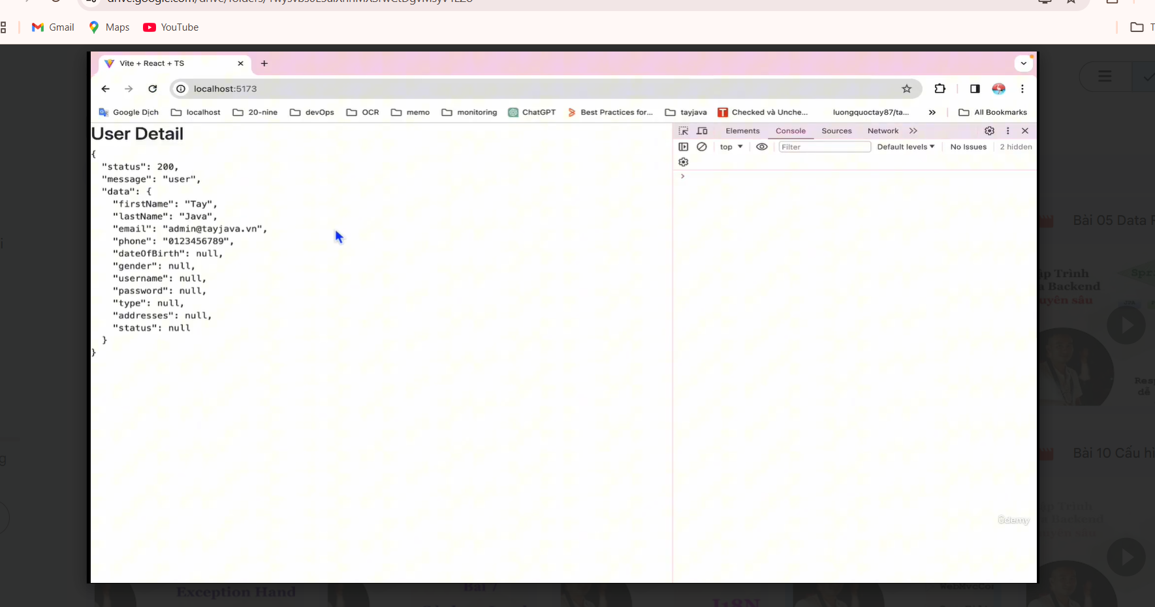

Tạo class AppCongig trong package configuration
C1: WebMvcConfigurer
package vn.hoangtojava.configuration;
import org.springframework.context.annotation.Configuration;
import org.springframework.web.servlet.config.annotation.CorsRegistry;
import org.springframework.web.servlet.config.annotation.WebMvcConfigurer;
@Configuration
public class AppConfig implements WebMvcConfigurer {
@Override
public void addCorsMappings(CorsRegistry registry) {
registry.addMapping("/**")
.allowCredentials(true)
.allowedOrigins("http://localhost:5173")
.allowedMethods("*")
.allowedHeaders("*");
}
}

C2: Cor Filter
package vn.hoangtojava.configuration;
import org.springframework.web.filter.CorsFilter;
//import org.apache.catalina.filters.CorsFilter;
import org.springframework.boot.web.servlet.AbstractFilterRegistrationBean;
import org.springframework.boot.web.servlet.FilterRegistrationBean;
import org.springframework.context.annotation.Bean;
import org.springframework.context.annotation.Configuration;
import org.springframework.core.Ordered;
import org.springframework.web.cors.CorsConfiguration;
import org.springframework.web.cors.UrlBasedCorsConfigurationSource;
import org.springframework.web.servlet.config.annotation.CorsRegistry;
import org.springframework.web.servlet.config.annotation.WebMvcConfigurer;
import java.util.List;
@Configuration
public class AppConfig {
@Bean
public AbstractFilterRegistrationBean<CorsFilter> corsFilter(){
UrlBasedCorsConfigurationSource source = new UrlBasedCorsConfigurationSource();
CorsConfiguration config = new CorsConfiguration();
config.setAllowedOrigins(List.of("http://localhost:5173", "http://localhost:5174"));
config.setAllowedMethods(List.of("POST","PUT","DELETE","GET"));
config.setAllowedHeaders(List.of("*"));
config.setAllowCredentials(true);
source.registerCorsConfiguration("/**", config);
FilterRegistrationBean bean = new FilterRegistrationBean<>(new CorsFilter(source));
bean.setOrder(Ordered.HIGHEST_PRECEDENCE);
return bean;
}
}

C3: OncePerRequestFilter
package vn.hoangtojava.configuration;
import jakarta.servlet.FilterChain;
import jakarta.servlet.ServletException;
import jakarta.servlet.http.HttpServletRequest;
import jakarta.servlet.http.HttpServletResponse;
import org.springframework.stereotype.Component;
import org.springframework.web.filter.CorsFilter;
//import org.apache.catalina.filters.CorsFilter;
import org.springframework.boot.web.servlet.AbstractFilterRegistrationBean;
import org.springframework.boot.web.servlet.FilterRegistrationBean;
import org.springframework.context.annotation.Bean;
import org.springframework.context.annotation.Configuration;
import org.springframework.core.Ordered;
import org.springframework.web.cors.CorsConfiguration;
import org.springframework.web.cors.UrlBasedCorsConfigurationSource;
import org.springframework.web.filter.OncePerRequestFilter;
import org.springframework.web.servlet.config.annotation.CorsRegistry;
import org.springframework.web.servlet.config.annotation.WebMvcConfigurer;
import java.io.IOException;
import java.util.List;
@Component
public class AppConfig extends OncePerRequestFilter {
@Override
protected void doFilterInternal(HttpServletRequest request, HttpServletResponse response, FilterChain filterChain) throws ServletException, IOException {
response.setHeader("Access-Control-Allow-Origin", "http://localhost:5371");
response.setHeader("Access-Control-Allow-Credentials", "true");
response.setHeader("Access-Control-Allow-Method", "*");
response.setHeader("Access-Control-Allow-Header", "*");
filterChain.doFilter(request,response);
}
}

